There is one error that I would need LABKEY Support to help with:

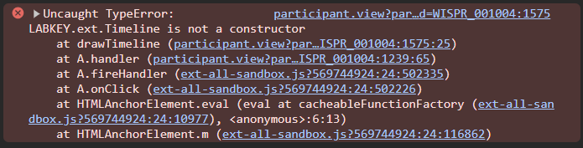

Custom views with “Timeline” tab encounter this JS error message. I believe the reason is that LABKET.ext.Timeline is no longer the method to create a new timeline object. However, I was not able to find the updated method on LABKEY Documentation. And the affected pages are following:   
<https://www.itntrialshare.org/study/Studies/ITN029STOPR/Study%20Data/participant.view?participantId=WISPR_001004>

<https://www.itntrialshare.org/study/Studies/ITN030STOPR/Study%20Data/participant.view?participantId=AWISH_001090>

Attached files are full custom codes for these two studies, and the responsible section of the code is following (specially the line colored in orange):

function drawTimeline()

        {

*if*(debug)console.log('drawTimeline called');

**timePanel = new LABKEY.ext.Timeline({**

                renderTo: 'timelinePanel',

                eventStore: eventStore,

                bands: [{

                    store: seriesStore,

                    series: [

                        { id: 'ALT', caption: 'ALT', lineColor: '#ff0000', yRange: 100 },

                        { id: 'GGT', caption: 'GGT', lineColor: '#000000', yRange: 100 }

                    ]

                }, {

                    store: seriesStore,

                    series: [

                        { id: 'B--', caption: 'Memory B cells (IgD-IgM-)', lineColor: '#ff0000', yRange: 50 },

                        { id: 'B+-', caption: 'Memory B cells (IgD+IgM-)', lineColor: '#0000ff', yRange: 50 },

                        { id: 'B-+', caption: 'Memory B cells (IgD-IgM+)', lineColor: '#000000', yRange: 50 },

                        { id: 'T', caption: 'T regulatory cells', lineColor: '#008888', yRange: 10 }

                    ]

                }

                ]

            });

*if* (!timePanel)

                console.log("Error", "Could not create timePanel.");

            timelineDrawn = true;

*if*(debug)console.log('drawTimeline done');

        }

Let me know if you have any questions regarding this.

Xin Chen [xchen@immunetolerance.org](mailto:xchen@immunetolerance.org)

++++++++++++++++++++++++++++++++++++++++++++++++++++++++++++